Phased Architecture — Smile-rapport (Deterministic Driver → Blocks → Template NLG)
This document translates your four phase diagrams into a concrete, phased architecture: what each phase does, the modules inside it, and what goes in / comes out of each step. The intent is a fully deterministic pipeline: drivers decide → blocks selected/suppressed → templates rendered → trace + QA.

The 4 Phases at a Glance
- Phase 1 — Intake & DriverState
Turn raw questionnaire answers into a complete, evidence-backed DriverState bundle (with completeness/conflict flags).
- Phase 2 — Safety & Content Selection (L1 + L2)
Use DriverState to activate Layer-1 safety/override blocks and select Layer-2 content blocks, then apply suppressions + cardinality to produce the final A_* + B_* block set.
- Phase 3 — Language Packaging (Tone + Templates)
Take the final block set and apply Layer-3 tone profiles (per-block, exactly one), then render fixed templates with placeholders to produce the final report text + outline + logs.
- Phase 4 — QA & Governance (Trace + Tests)
Collect full traces (inputs, drivers, blocks, tone), run regression + semantic leakage checks, flag violations, store audit record, and generate a QA summary.

Phase 1 — Intake & DriverState
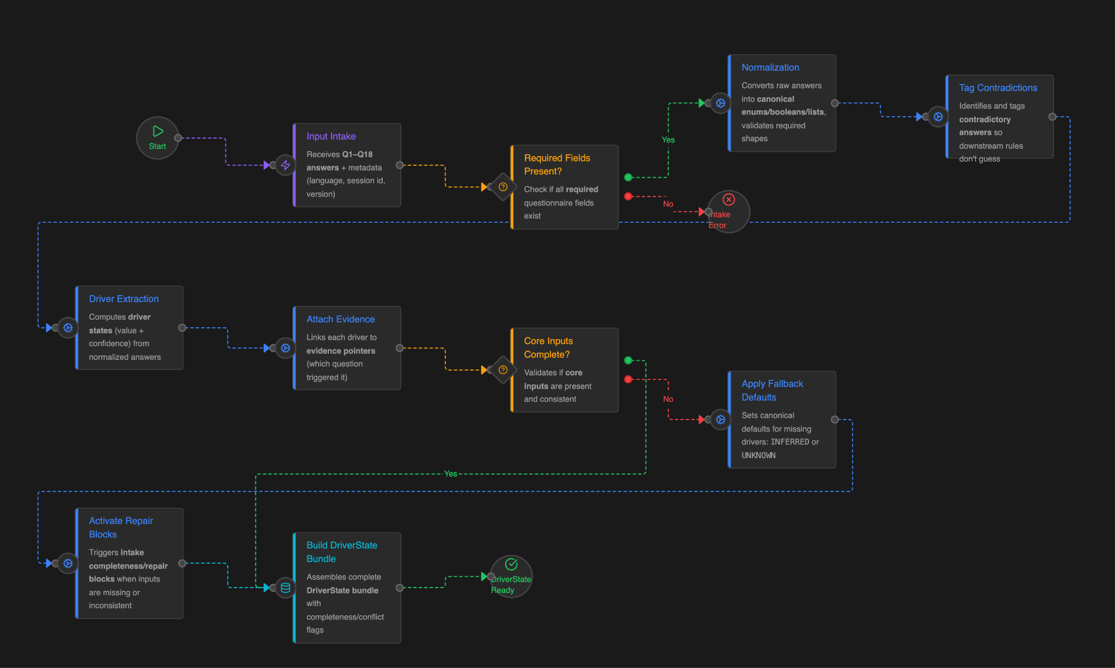

Goal
Produce a complete DriverState bundle from Q1–Q18 answers, with: - canonicalized values, - confidence and evidence pointers, - completeness + contradiction flags, - fallback defaults when needed (without guessing).

Modules (in diagram order) + I/O

1) Input Intake
In: Raw Q1–Q18 answers + metadata (language, session_id, version).
Out: Raw intake package.

2) Required Fields Present?
In: Raw intake package.
Out: (Yes) proceed, (No) “Intake Error” (hard stop or user re-prompt, depending on product UX).

3) Normalization
Meaning (mechanics): convert raw answers into canonical forms so routing rules are stable and testable.
Examples: - map strings → enums (e.g., “Yes/No/Unsure” → TRUE/FALSE/UNKNOWN), - normalize multi-select into canonical lists (deduped, stable order), - coerce numbers/ages into buckets, - validate required shapes (no empty where required).
In: Raw intake package.
Out: NormalizedAnswerSet (canonical enums/booleans/lists).

4) Tag Contradictions
In: NormalizedAnswerSet.
Out: Contradiction tags (do not resolve; just label) + updated NormalizedAnswerSet.

5) Driver Extraction
In: NormalizedAnswerSet.
Out: Partial DriverState bundle (values + confidence).

6) Attach Evidence
In: Partial DriverState + NormalizedAnswerSet.
Out: DriverState bundle where each driver is linked to evidence pointers (which question/option triggered it).

7) Core Inputs Complete?
In: DriverState bundle + contradiction tags.
Out: (Yes) continue, (No) proceed with guarded defaults + “repair” logic.

8) Apply Fallback Defaults
In: DriverState bundle.
Out: Completed DriverState bundle where missing drivers are set to INFERRED or UNKNOWN (never upgraded to CONFIRMED).

9) Activate Repair Blocks
In: Completed DriverState bundle + completeness/contradiction flags.
Out: Intake/repair block intents (these become candidates for Layer-1 intake blocks in Phase 2).

10) Build DriverState Bundle (final)
In: DriverState + flags.
Out: Final DriverState bundle + completeness/conflict flags (“DriverState Ready”).
Phase 1 Output Contract:
DriverStateBundle { drivers[], evidence[], completeness_flags, conflict_flags, version, session_id }

Phase 2 — Safety & Content Selection (L1 + L2)
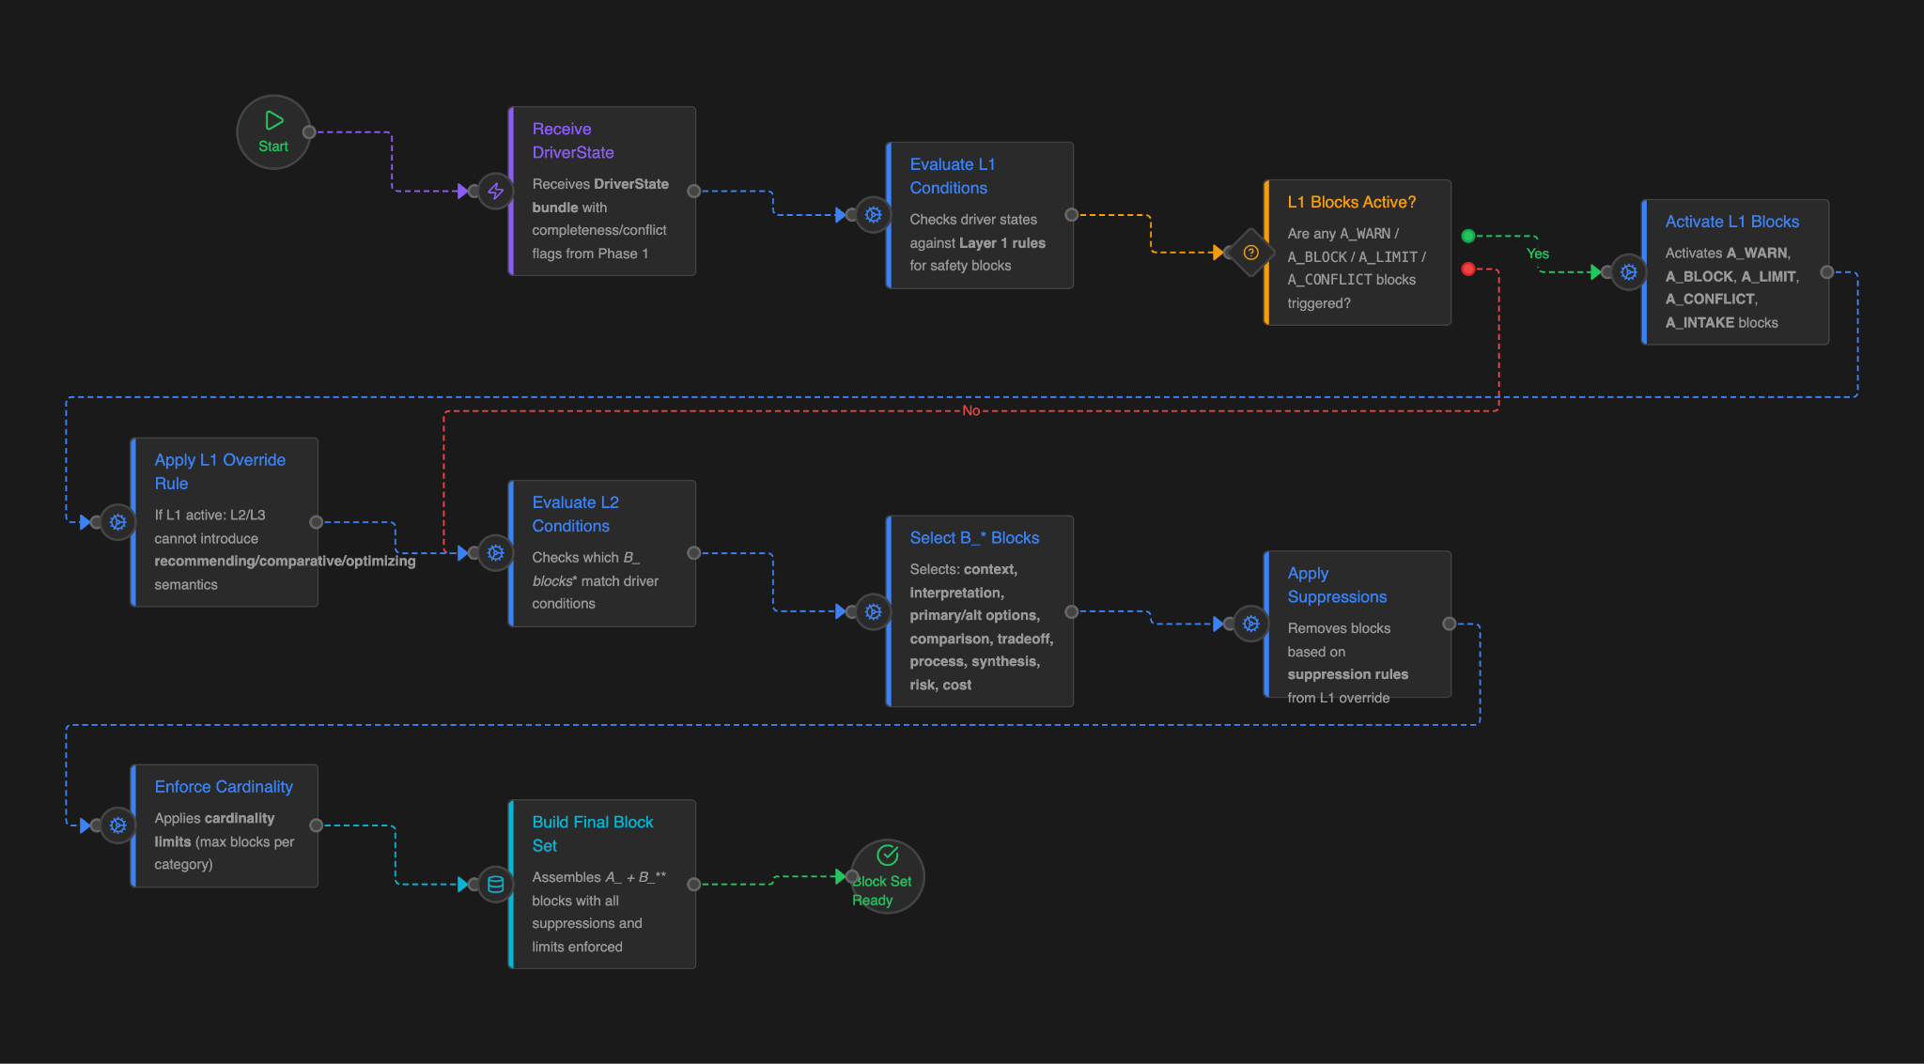

Goal
Turn DriverState into a final block set: - Layer 1 (A_): warnings / hard blocks / limits / conflicts / intake gates (safety first) - Layer 2 (B_): content blocks (context, interpretation, options, comparison, process, synthesis, risk language, etc.) …and ensure Layer-1 override semantics are enforced.

Modules (in diagram order) + I/O

1) Receive DriverState
In: DriverState bundle from Phase 1.
Out: DriverState bundle in routing context.

2) Evaluate L1 Conditions
In: DriverState bundle + completeness/conflict flags.
Out: L1 triggers (which Layer-1 rules fire).

3) L1 Blocks Active?
In: L1 triggers.
Out: branch decision (Yes/No).

4) Activate L1 Blocks
In: L1 triggers.
Out: Active Layer-1 block list (A_WARN_, A_BLOCK_, A_LIMIT_, A_CONFLICT_, A_INTAKE_*).

5) Apply L1 Override Rule
Meaning (mechanics): if any L1 block is active, L2/L3 may still exist structurally, but they must not introduce recommending/comparative/optimizing/CTA semantics.
In: Active L1 blocks + DriverState.
Out: a suppression/constraint policy (e.g., block categories disabled, phrase constraints, “no recommendation language”).

6) Evaluate L2 Conditions
In: DriverState bundle + L1 override policy.
Out: L2 activation decisions (which B_* blocks qualify to be included).

7) Select B_* Blocks
In: L2 activation decisions.
Out: Candidate Layer-2 blocks (B_CTX_, B_INTERP_, B_OPT_PRIMARY_, B_OPT_ALT_, B_COMPARE_, B_TRADEOFF_, B_PROCESS_, B_SYNTHESIS_, B_RISKLANG_*).

8) Apply Suppressions
In: Candidate A_* + B_* blocks + L1 override policy + suppression conditions (e.g., “clinical_block = true”, “data_confidence low”).
Out: Filtered blocks with explicit suppression reasons logged.

9) Enforce Cardinality
Meaning (mechanics): enforce max-per-category constraints (e.g., max 1 primary option block, max 1 alt option block, etc.).
In: Filtered block set.
Out: Cardinality-compliant block set (with decisions logged).

10) Build Final Block Set
In: Final A_* + B_* blocks + logs.
Out: “Block Set Ready” for Phase 3.
Phase 2 Output Contract:
BlockSet { blocks: [A_* + B_*], suppressions_log, cardinality_log, version, session_id }

Phase 3 — Language Packaging (Tone + Templates)
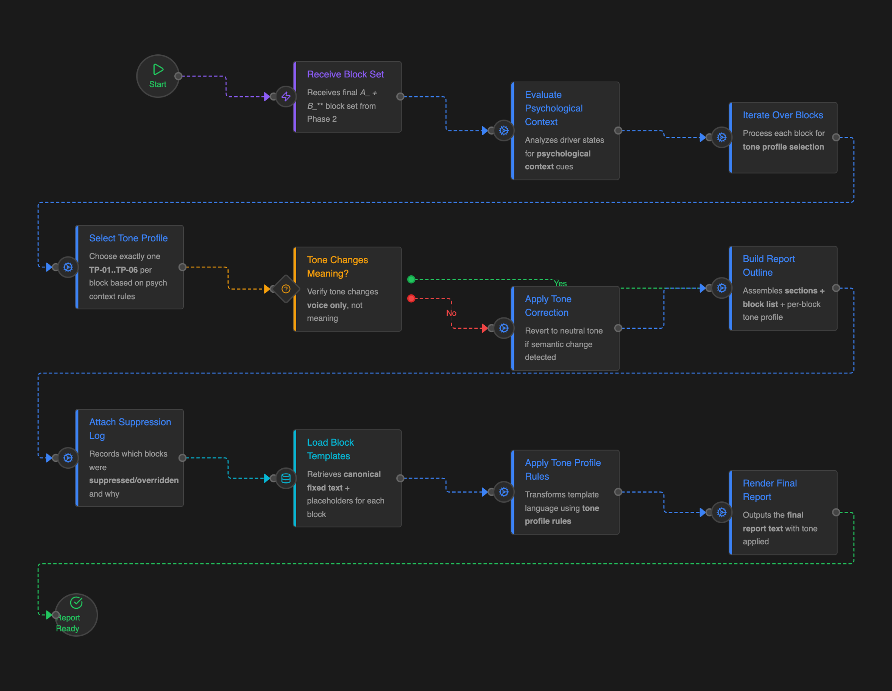

Goal
Render the report deterministically from the final block set: - choose exactly one tone profile per block (Layer 3), - apply tone rules without changing meaning, - load canonical templates (fixed text + placeholders), - output final report text + outline + per-block tone decisions + suppression log.

Modules (in diagram order) + I/O

1) Receive Block Set
In: BlockSet from Phase 2.
Out: BlockSet in rendering context.

2) Evaluate Psychological Context
In: DriverState (from trace context) + BlockSet.
Out: Tone drivers / psychological cues used for tone selection (C_* context).

3) Iterate Over Blocks
In: BlockSet + tone cues.
Out: Per-block tone selection jobs.

4) Select Tone Profile
Meaning (mechanics): choose exactly one TP-01..TP-06 per block (no inheritance, no combining).
In: Block + tone cues.
Out: Selected tone profile per block.

5) Tone Changes Meaning?
Meaning (mechanics): a guard check that tone variation remains “voice only” (no new claims, no reassurance, no CTA, no ranking language).
In: Drafted block text (or rule-level intent) + selected tone.
Out: (Yes safe) proceed, (No) correction path.

6) Apply Tone Correction
In: Block + tone profile that risked meaning change.
Out: Revert to safer tone (typically neutral) for that block; record correction.

7) Build Report Outline
In: BlockSet + per-block tone profiles.
Out: Ordered sections + block list + per-block tone tags (a rendering plan).

8) Attach Suppression Log
In: Suppressions log from Phase 2 + outline.
Out: Report package with full suppression provenance.

9) Load Block Templates
In: Block IDs from outline.
Out: Canonical templates (fixed text + placeholders) for each block.

10) Apply Tone Profile Rules
In: Templates + tone profiles + tone rules.
Out: Tone-adjusted templates (voice-only transforms).

11) Render Final Report
In: Tone-adjusted templates + placeholder values.
Out: Final report text (“Report Ready”).
Phase 3 Output Contract:
FinalReport { text, outline, tone_decisions, suppression_log, version, session_id }

Phase 4 — QA & Governance (Trace + Tests)

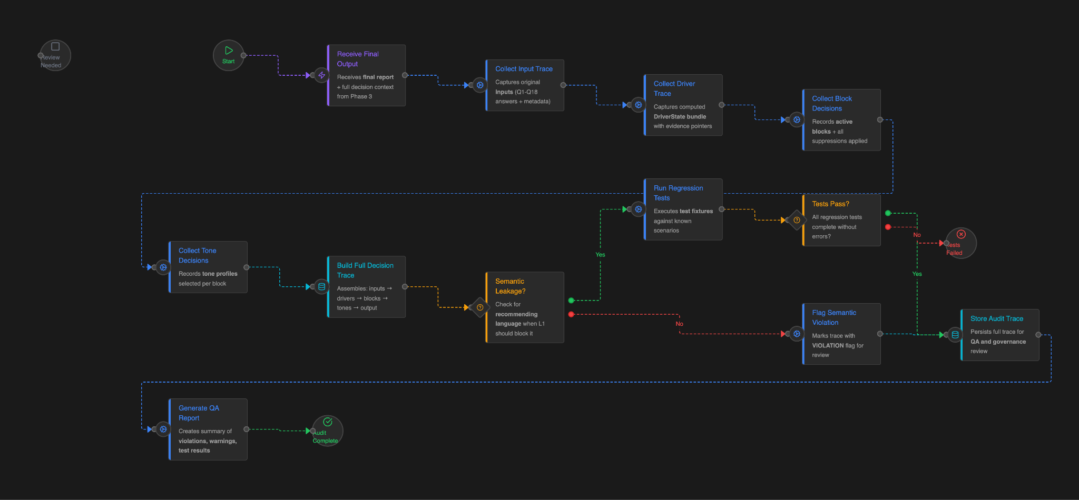

Goal
Make every report auditable and prevent silent regressions: - capture traces (inputs → drivers → blocks → tone), - run regression fixtures and safety checks, - flag semantic leakage, - persist an audit record, - produce a QA summary report.

Modules (in diagram order) + I/O

1) Receive Final Output
In: Final report + full decision context (from Phase 3).
Out: QA run context.

2) Collect Input Trace
In: Raw inputs (Q1–Q18 + metadata).
Out: InputTrace record.

3) Collect Driver Trace
In: DriverState bundle + evidence pointers.
Out: DriverTrace record.

4) Collect Block Decisions
In: Final block set + suppressions applied.
Out: BlockDecisionTrace record.

5) Collect Tone Decisions
In: Tone profiles selected per block.
Out: ToneDecisionTrace record.

6) Build Full Decision Trace
In: InputTrace + DriverTrace + BlockDecisionTrace + ToneDecisionTrace + final text.
Out: FullDecisionTrace (single object, audit-ready).

7) Semantic Leakage?
Meaning (mechanics): check for recommending/comparative/optimizing language when L1 says it must be blocked/limited; detect forbidden phrases/structures.
In: Final report text + active L1 blocks + constraints.
Out: pass/fail + violation details.

8) Run Regression Tests
In: Test fixtures (known scenarios) + current rule/template pack.
Out: pass/fail + diff summary.

9) Tests Pass?
In: Regression + semantic checks.
Out: branch decision: - No → “Tests Failed” (stop release / mark run failed) - Yes → proceed

10) Flag Semantic Violation
In: Violation details.
Out: Trace flagged for review (Review Needed).

11) Store Audit Trace
In: FullDecisionTrace + status flags.
Out: Persisted audit record (for QA/governance).

12) Generate QA Report
In: Audit record + test results + violations/warnings.
Out: QA summary (“Audit Complete”).
Phase 4 Output Contract:
AuditArtifacts { decision_trace, regression_results, leakage_results, status, qa_summary, version }

What This Gives You (Practically)
- A clean separation: drivers & rules decide, templates only render.
- L1 override semantics enforced structurally (not “by convention”).
- A trace for every report that answers: what fired, what was suppressed, why.
- A release process where regressions/leakage are catchable before shipping.

Appendix — Recommended Naming Conventions (Aligns with your docs)
- DriverState: computed driver value + confidence + evidence pointer(s)
- A_* blocks: Layer 1 safety/constraint/override library
- B_* blocks: Layer 2 canonical content blocks (context → interpretation → options → compare → process → synthesis → risk language)
- TP-: Layer 3 tone profiles applied per block, voice-only
- Suppression log: explicit reasons why blocks were removed/neutralized
- Decision trace: the single audit object spanning phases 1–4

